UNIT 1
Chassis Frame and Body
1
1.1 Introduction of Chassis Frame
Chassis frame is the basic frame work of the automobile. It supports all the parts of the automobile attached to it. It is made of drop forged steel. All the parts related to automobiles are attached to it only. All the systems related to automobile like powerplant,transmission, steering, suspension, braking system etc are attached to and supported by it only.
1.2 Layout of Chassis and its main components
“Chassis” a French term which means the complete Automobiles without Body and it includes all the systems like power plant, transmission, steering, suspension , wheels tyres , auto electric system etc. without body. If Body is also attached to it them it is known as the particular vehicle as per the shape and design of the body.

1.3 The Functions of the Chassis frame
1. To carryall the stationary loads attached to it and loads of passenger and cargo carried in it .
2. To withstand torsional vibration caused by the movement of the vehicle
3. To withstand the centrifugal force caused by cornering of the vehicle
4. To control the vibration caused by the running of the vehicle
5. To withstand bending stresses due to rise and fall of the front and rear axles.
1.4 Types of Chassis frame
There are different types of chassis frame sections
1. Channel section
2. Box section
3. Tubular section
The conventional frame is also known as Non-load carrying frame. In this types of frame , the loads on the vehicle are transferred to the suspension by the frame which is the main skeleton of the vehicle.
The channel section is used in long members and box section in short members. Tubular section is used now-a-days is three wheelers, scooters, matadors and pickup vans.
The frames should be strong enough to bear load while sudden brakes and accidents.
1.5 Various loads acting on the Chassis frame
The loads acting on the chassis frame are as follow
1. Stationary loads namely the loads of permanent attachment like all the parts of the chassis, body etc.
2. Short duration loads while turning , braking etc.
3. Momentary loads while quick acceleration , sudden braking etc.
4. Loads applied while crossing roads of irregular and uneven sur
1.6 Different Bodies used in Automobiles
The automobiles bodies are designed according to the requirement of the vehicle. According to design and requirement of the vehicle , there are different types of Automobiles bodies. Some of them are listed as below :
(i) Car
(ii) Straight truck or Punjab truckbody
(iii) Truck with half body
(iv) Platform type truck
(v) Tractor
(vi) Tractor with articulate trailer (vii) Tanker
(viii) Bus
(ix) Dumper truck
(x) Delivery van
(x) Station wagon

(xi) Pick up van (xii) Jeep
(xiv) Long wheel base truck etc
1.7 Requirement of Bodies for various types of vehicle
According to requirement , automobile bodies are classified mainly into different types namely private vehicle, commercial vehicle, fleet transport vehicle, passenger transport vehicle, Ambulances vehicle used for transport of Army personal, Ammunition etc., different types of tanker vehicle etc. If it is a private vehicle, the vehicle is used for luxury personal travelling , private cargo transport etc, namely car , mini van , Omni bus, matador etc.
If it is commercial vehicle the vehicle is used for transportation of goods some other vehicles, freezer boxes etc. If it is tanker, it is used to transport milk , water, edible oils, petroleum products , gases , acids etc. The tanker bodies are designed according to the relevant requirement .

If it is an army vehicles, the vehicle are separately designed namely Arm truck, heavy long wheel base cargo trucks , long platform trucks etc. These are exclusively used to carry the army personal, arms and ammunitions etc.
Some automobiles manufacturing companies are using long wheel base trucks with closed body structure for transporting of the vehicle produced in their factories to different market outlets.
The private vehicles used in different fields namely Buses of different types, air conditioned Buses, station Wagons etc, Usually Road Transport organization of a state is a fleet organized jointly by the state Government an exclusive body which is to operate buses for travelling of passenger to various places within the state as well as Inter-State travelling also the Road transport corporation organization is having differently designed buses namely ordinary body buses, Deluxe buses , semi luxury buses, Air conditioned buses and also buses with sleeper coach etc.
Short Answer Type Questions
1. Define chassis.
2. Mention the types of chassis frame
3. What is the purpose of chassis frame?
4. Mention any eight types of automobile bodies.
Long Answer Type Questions
1. List out the functions of chassis frame.
2. Mention various loads acting on chassis frame.
3. Discuss about the requirements of different automobile bodies.

Unit 2
Steering System
2

Structure
2.1 Requirement of vehicle steering system
2.2 Types of steering Gear boxes
2.3 Types of Steering systems and power steering.
2.4 Steering linkages
2.5 Under Steering, Over steering and Turning Radius.
2.6 Steering gear mechanisms.
2.7 Steering geometry - Caster, Camber, Kingpin inclination, toe-in and toe-out.
2.8 Steering defects - wheel wobble and shimmy.
2.9 List out the types of steering systems used in various vehicles.
Learning Objectives
After studying this unit ,the student should be able to learn the
(i) Requirement of vehicle steering
(ii) Types of steering system
(iii) Types of steering gears and their application in various vehicles.
2.1 Requirements of Vehicle Steering System
The steering system of a vehicle is having the following requirements
(1) It should be able to turn the vehicle with more mechanical advantage and less efforts.
(2) It should turn the wheel within shortest possible time
(3) There should be self-centering action in the steering geometry

2.2 Types of Steering Gear Xoxes
1. Worm and wheel steering gear
2. Worm and roller steering gear
3. Worm and sector steering gear
4. Can and lever steering gear
5. Rack and pinion steering gear
6. Re circulating ball steering gear
2.3 Types of Steering system
The steering system is said to be of different types according to its position along with the vibration of front wheels.
When deflection of the steered wheels due to road surface is transmitted through the steering linkage and steering gear box to the steering wheel, the system is said to be “Reversible steering”
If every small imperfection of the road surface cause the steering to rotate it is known as Reversible steering . But it is not advisable. Some degree of reversibility is needed so that the wheels will find to strength up after negotiating a bending. This effect is called semi reversible . When steered wheels do not cause any deflects due to road irregularities it is known as irreversible steering. The semi reversible steering is always desired.
Power Steering
The power steering system provides additional assistance to the turning effort applied to the manual steering system.
The power steering is of two types - Hydraulic and electric/ electronic . A hydraulic -electric hybrid system is also possible.
A hydraulic power steering (HPS) used hydraulic pressure applied by on engine driven pump to assist the motion of turning the steering wheel.

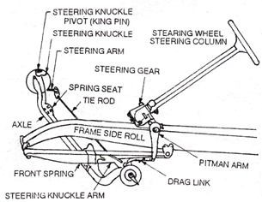

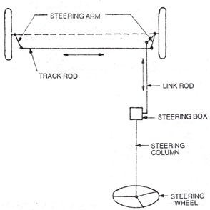

Automobile Engineering Technician
When the steering wheel is turned to the left or right , the pitman arm swings from one side to the other. This movement of the pitman arm gives angular movement to the front wheels through the steering linkage.
The most commonly use steering linkage is conventional steering linkage. The pitman Arm (drop arm) is connected directly by a connecting link namely drag link to a steering knuckle arm attached to the left hand steering knuckle. The motion is carried across from this arm to a steering arm on the right side steering knuckle by means of the rod. The drag link and drop arm (Pitman Arm) are mounted on the left side of the frame.
In some designs the drag link is connected between the drop arm and right steering knuckle arm by locating drop arm beneath the steering gear.
In direct cross type steering linage, the pitman arm (Drop Arm) is connected directly to one and of the rod which its turn is connected to another. The other ends of the rods are connected to the steering arms.

Fig 2.7 Conventionaal steering linkage

2.5 Under Steering, Over steering and Turning Radius
While taking a turn, the wheels are not always pointing in direction in which the vehicle is moving, due to distortion of tyretread. The angle between the wheel inclination and the path taken by the wheel is known as “Slip angle” . When the slip angle is greater at the rear than of the front, the vehicle tends to “over steer” the vehicle is to turn into the curve more than the driver intended.

2.6 Steering Gear Mechanism
There are two types of steering gear mechanism.
1. Davis steering gear
2. Ackerman steering gear
The Davis steering gear has sliding pairs, whereas the Ackerman steering gear has only turning pairs. The sliding pair has more friction than the turning pair. Therefore the Davis steering gear will wear out earlier and become inaccurate after certain time.
Although, the Ackerman steering gear is not mathematically accurate except in their position, contrary to the Davis steering gear which is mathematically correct in a position
However, Ackerman steering gear is preferred to Davis steering gear
Davis steering Gear : The Davis steering gear mechanism consist of a cross link “KL” sliding parallel to another link “AB” and its connecting to the stub axles of the two front wheels by means of two similar bell crane levers “ACK” and “DBL” pivoted at “A” on the “B” respectively. The cords link “KL” slides on the bearing and carries pins at its ends “K” and “L”. The slide blocks are pivoted on these pins and move with the turning of bell crane levers as the steering wheel is operated. When the vehicle is running straight, the gear is said to be in mid position. The short Arms “AK” and “BL” are inclined at an angle of “90 + 0C” to their stub axles “AC” and “BD” respectively

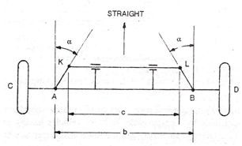

102 Automobile Engineering Technician

b
Tan =
2l
Where b = AB = distance between the points of front axles. l = wheel base
The range of b/l is 0.4 to 0.5
Hence the angle “” lies between 11.3º and 14.1

Fig 2.8 Davis steering gear mechanism
Ackerman steering gear : The Ackerman steering gear mechanism consist of cross link “KL” connected to the short axels “AC” and “BD” of the two front wheel through the sort arms “AK” and “BL” forming bell crane levers CAKL and BDKL respectively .
When the vehicle is taking a turn, the inside wheel must follow a tight curve than the outside wheel .
When the vehicle is running straight the cross link “KL” is parallel to “AB” the short arms “AK” and “BL” both make angle  to the horizontal axis of chassis.
The angles 0 and  are shown in figure. The value of b/L is between 0.4 to 0.5.
For correct steering
Cot  - cot  = b/l.
In Ackerman steering gear, there are three positions to be observed infact. The value of  will be different as the vehicle is running straight, vehicle is taking a left turn and vehicle is taking a right turn.

Dcvfdgop[
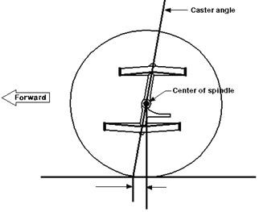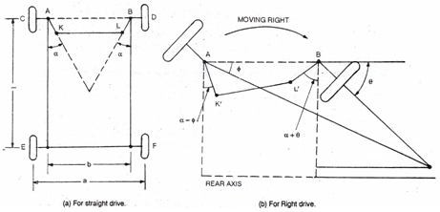

Paper - II Auto Chassis and Body Engineering 103

Fig 2.9 Ackerman steering gear
2.7 Steering geometry - Caster, Camber, Kingpin inclination, toe-in and toe-out.
Steering Geometry : It refers to the positioning of the front wheels and steering mechanism that gives the vehicle directional stability , promotes ease of steering and reduces tyre wear to a minimum. It also refers to the angular relationship between the front wheels and parts attached to the front wheel, frame of the vehicle. It depends upon the following terms. Caster angle, camber angle, King Pin inclination , Toe-in Toe-Out on turn.
Caster angle: It is the angle of tilting the king pin axis either forward or backward from the vertical line. This tilting is known as Caster. The angle between the vertical line and the king pin centre line in the plane of the wheel (When viewed from the side) is called the Caster angle.

104 Automobile Engineering Technician
When the top of the king pin is backward, the caster angle is positive, and when it is forward, the caster angle is negative. Usually the caster angle in modern vehicles ranges from 2 to 8 degrees.
The main purpose of caster angle is to create self centering effect in the steering. It provides the directional stability. It positive caster increase the efforts required to steer and tries to keep the wheels straight ahead. In heavy duty trucks negative caster is preferred. This makes the steering easier.
Camber Angle : It is the angle between the centre line of the tyre and the vertical. When viewed from the front of the vehicle when the angle is outward, so that the wheels are farther apart at the top the camber is “Positive” when the angle is inward, so that the wheels are closer together at the top, the camber is “Negative”. The usual value of camber angle should not exceed 2º.
When the camber angle is positive, it causes slip out prevention lightens the perpendicular load and lessen the required steering effort. If it is a Zero camber, it prevents uneven wear of tyres. When the camber angle is negative, the camber thrust increase with increase in tyre inclination relative to the road surface.

- Negative + Positive

CAMBER

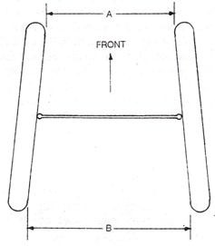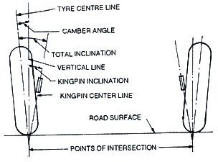

Paper - II Auto Chassis and Body Engineering 105
King Pin Inclination or steering Axis Inclination
It is the angle between the vertical line and the center of the King pin the steering axis when viewed from the front. The Kingpin inclination, in combination with caster angle, is used to provide directional stability . It also reduces steering effort particularly when the vehicle is stationary. It reduces tyre wear also. The kingpin inclination in modern vehicle ranges from 4º to 8º. It is also known as steering Axis inclination.

Fig 2.12 King pin inclination
Toe-In : It is the inward tilting of front wheels at the front so that the distance between the front wheels at the front is less than the distance between at the front wheels at the rear when viewed from the top. The Amount of the Toe-in is usually 3 to 5 mm .

Fig 2.13Toe-in

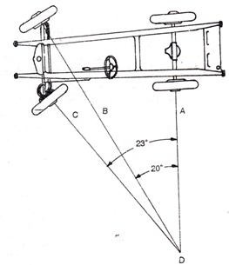
The toe-in is provided to ensure parallel rolling of the front wheels to stabilize steering and prevent side slipping of front wheels and thereby prevent excessive tyre wear.
Toe-Out : Toe-out is the differenence in angles between the two front wheels and the car frame during turns. The steering system is designed to the turn the inside wheel through a larger angle than the outside wheel when making a turn. The toe-out is secured by providing the proper relationship between steering knuckle arms, tie rods and pitman arm (drop arm).

Fig 2.14 Toe-out
2.8 Steering defects - Wheel Wobble and Shimmy
(i) Wheel wobble and shimmy : when the vehicle go through an uneven or rough road, the front wheel will get shaken for a while. This problem can also be seen when the vehicle is slowing down. This problem may caused by the following reason.

Reason
1. Unbalanced wheels
2. Unevenly worn out tyres
Remedy
1. The wheels should be balanced at wheel balance
2 . Rotate the tyres or Replace with new ones if necessary

3. Inoperative shock absorbers 3. Replace them

4. Incorrect Toe-in
5. Loose spring U-Bolts
6. Loose steering linkages
7. Worn out kingpin stee

Short Answer Type Questions
1. What is the purpose of steering system?
2. Mention the types steering gears.
3. What is ship angle?
4. Define ‘Under steer’ and ‘Over steer’.
5. What is meant by Turning Radius?
6. Define castor angle. What is its usual value?
7. Define camber angle. Mention its usual value
8. What is king pin inclination?
9. Define Toe-in and write its usual value.
Long Answer Type Questions
1. Briefly explain recirculating ball steering gear with neat sketch?
2. Briefly explain Rack and Pinion steering gear with neat sketch.
3. Briefly explain power steering with diagram.
4. Briefly explain Ackerman steering principle with neat sketch.
5. Discuss about the steering defect - ‘Wheel Wobble

Unit 3

Braking System
3
3.0 Introduction
In Automobiles brakes play important role in slowing down and stopping of the vehicle as and when required by the driver. Fundamentally the brakes are of two types (i) Internal expanding (ii) External contracting type . Different types of brakes are used in different vehicles as per the requirement . According to application, the brakes are of different types-mechanical , hydraulic air, vacuum , Air assisted Hydraulic.
3.1 Functions of Brakes
(i) To slow down or to stop the vehicle as and when required.
(ii) To control the vehicle when the vehicle is rolling down on a slope road down ward.
(iii) To travel smoothly and safely even in heavy flow of traffic by controlling the movement of the vehicle.
3.2 Requirement of Automobile Brakes
(i) The brakes must stop the vehicle within shortest possible distance.
(ii) These must be released suddenly after releasing them (iii) Total control of the vehicle should be there
3.3 Stopping time and Stopping Distance
The stopping time and stopping distance shows the efficiency of brakes.
The maximum retarding force applied by the brake at the wheels, F, depends upon the coefficient of friction between the road and tyre surface  and the component of the weight of the vehicle on the wheel, w.
F =  w
In actual practice 100% of brakes efficiency is not used. The stopping time and distance depend upon
(i) Vehicle speed
(ii) Condition of road surface (iii) Condition of tyre tread.
(iv) Coefficient of friction between the tyre tread and road surface.
(v) Coefficient of friction between brake drum and brake lining (in case of Drum brakes).

(vi) Coefficient of friction between the disc and the friction pad (in case of Disc brakes).
(vii) Brake force applied by the driver.
However, during emergency braking, the reaction of the driver and response time of the brakes also play an important role. The total stopping distance in case of emergency braking may be divided into three parts :
(i) Distance travelled during the reaction time of the driver.
(ii) Distance travelled between the time elapsed between driver pressing the brake pedal and actual application of brakes at wheels.
(iii) Net stopping distance, depending upon the deceleration.
Keeping all the factors in view, the assumed brake efficiencies for some of the vehicle may be like the valves given in the table approximately.

Efficiency % Approximate stopping distance (in metres) for the speeds
30Km/H 50 Km/H 80 Km/H 100 Km/H
100 3.5 9.8 25.2 39.3
80 4.4 12.2 31.5 49.1
60 6.0 16.3 42.0 65.5
30 12.0 32.6 84.0 131.0

These values depend upon the distance travelled during the reaction time of the driver and distance travelled between applying pedal and actual application of brakes at wheels.
3.4 Types of Braking system - Disc and Drum Braking system
Disc Brakes
The disc brake consists a cast iron disc bolted to the wheel hub and a stationary housing called calliper. The Calliper is connected to some stationary part of vehicle, like axle casing or the stab axle and is cast in two parts, each part containing a piston. In between each piston and the disc, there is a friction pad held in position by retaining pins, spring plates etc.

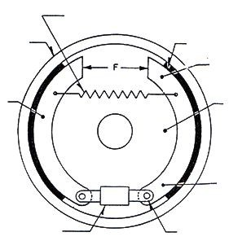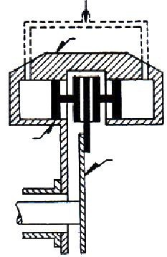

Paper - II Automobile Chassis and Body Engineering 113
Fluid from Lines

Caliper

Actuating piston
with friction pad
Revolving Disc

Fig 3.1 Disc Brake
When the brakes are applied, hydrautically actuated piston move the friction pads into contact with the disc, applying equal and opposite forces on the later. On releasing brakes, the rubber sealing rings act as return springs and retract the pistons and the friction pads away from the disc.
Drum Brakes
Retracting spring
Brake Drum Brake Lining
Toe of Shoe

Brake Shoe Back Plate

Heel of shoe

Adjuster Anchor

Fig 3.2 Drum Brake

114 Automobile Engineering Technician
In this type of brakes, a brake drum is attached concentric to the axle hub whereas on the axle casing is mounted a back plate. In case of front axle, the brake plates are bolted to the steering knuckle. The back plate is made of pressed steel and is ribbed to increase rigidity and to provide support for the expanding brake shoes. These brakes are also known as internal expanding brakes.
3.5 Construction and working of Mechanical, Hydraulic and Air brakes.
3.5.1 Construction and working of Mechanical Brakes
These brakes are operated completely through mechanical links and lever. These are applied in two wheelers and these wheeler. These are also applied in four wheeler as parking or Emergency brakes . In the wheel drum there are two brake shoes which are linked closely by a retracting spring. There will be a can between the two shoes. When brake pedal is applied, the can will rotate causing the brake shoes expand against the force of the returning spring. This causes the shoes to rub against rotating wheel drum and thereby stopping it. When brake pedal is released, the can inside wheel drum will come back to its position causing the brake shoes to come back with the presence of returning position and thus releasing brakes.
3.5.2 Construction and working of hydraulic brakes
The hydraulic brakes are being operated in the Pascal’s law which states that “The pressure applied on any liquid is equally transmitted to all the direction at the same time”. In the same manner the pressure of brake pedal which is applied on the brake fluid in the master cylinder is transmitted to all the four wheel cylinder with equal pressure and at the same time. In this way the brake shoes which are attached to the wheel cylinder (s) are expanded and thus the brakes are applied.
The parts of hydraulic braking system one (i) Brake pedal (ii) Pull and push rod (iii)- Master cylinder (iv) Brake pipe lines (v) wheel cylinder (vi) brake shoes .
When the brake pedal is applied the piston inside the master cylinder in pushed forward and it caused the pressurized brake fluid moves forward to all the four wheel cylinder at the same time with same pressure. There at the wheel cylinder the brakes shoes will be expanded with the developed pressure in the wheel cylinder. All the wheel cylinder will be operated at the same time according to Pascal’s law. This is how the brakes are applied. While releasing brakes with contracting of brake shoes with spring force the brake fluid in the

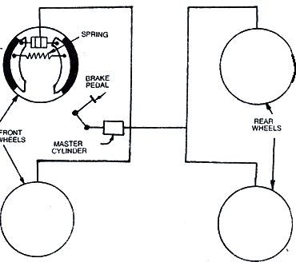

Paper - II Automobile Chassis and Body Engineering 115
wheel cylinder will try to go back to the master cylinder. As there is no pressure on the position of the master cylinder, the brake fluid push the check valve of master cylinder and the enter into the reservoir through barrel and by pass valve of master cylinder.

Fig 3.3 Hydraulic Brake System
Master cylinder
It is the most important part of hydraulic braking system . It contains two main chambers .
(i) Fluid reservoir - which stores the brake fluid in it
(ii) Barrel-which is compressor and develops pressure in brake fluid
(i) Reservoir : The reservoir also contains two parts . The larger part is called filler or intake port and the smaller port is called by pas through which the returned fluid from the system will enter into reservoir from barrel.
(ii) Barrel : In the barrel of master cylinder the parts are - (a) Primary cup (b) Position (c) Secondary cup (d) Return spring (d) Return spring (e) Check value .
When the brake pedal is applied the push rod will push the piston of master cylinder and there by the pressure is applied on the Hydraulic Brake fluid. The pressurized brake fluid will enter into system through check valve

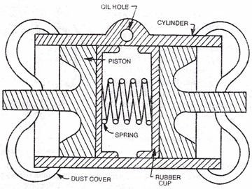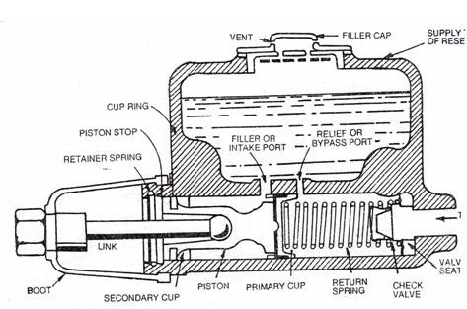

116 Automobile Engineering Technician
which does not allow the fluid to return back. This causes the pressure on the system and applying brakes at the wheel cylinder.

Fig 3.4 Master Cylinder
Wheel cylinder

Fig 3.5 Wheel Cylinder

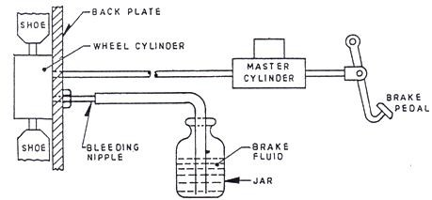

Paper - II Automobile Chassis and Body Engineering 117
Wheel cylinder or slave cylinder assist the main master cylinder in covering the pressure to the piston inside it and push the brake shoes attached to it . Some of the wheel cylinder having one piston and some having two pistons. The wheel cylinder having one piston will operate only one brake shoe and the two wheel cylinder are require to operate two brake shoes. In some wheel cylinder, both brake shoes are operated as they are having two piston in them.
When brakes are applied the brake fluid enter into the cylinder through a brake pipe line. It cause to force out the piston. This motion is transmitted to brake shoes causing them to expand against the running wheel drum to hold it tightly and stop it. .
3.6 Bleeding of brakes in Hydraulic brakes.
In Hydraulic Brakes, the removal of air from the entire Hydraulic system starting from master cylinder to different wheel cylinders is known as Brake Bleeding

Fig 3.6 Wheel Cylinder
It includes the following process :
(i) At first check all the pipe lines and junction boxes from master cylinder to wheel cylinder. Whether there is any leak among them.
(ii) Ask one person to pump the brake pedal and keep it in pressing position
(iii) The second person should loosen the bleeding nipple at the back plate of the wheel cylinder position.

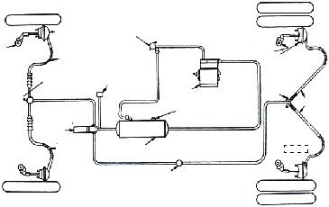

118 Automobile Engineering Technician
(iv) Keep the bleeding nipple in open until the air bubbles disappear and the brake fluid comes out with a force . Collect the brake fluid in a glass tumbler.
(v) Then tighten the bleeding nipple
(vi) Repeat this process in all the wheel cylinders starting from the farthest wheel to the master cylinder and ending with the nearest
wheel.
(vii) Make sure that the level of brake fluid in master cylinder is ¼ less than the top covers while filling it.
Air Brakes
The manufacturers of braking systems offer a variety of air brake equip-ment. However, the simplest system consists of an air compressor, a brake valve, series of brake chambers, unloader valve, a pressure gauge and a safety valve. These are all connected by lines of tubing. The other braking systems may have additional components such as stop-light switch, a low pressure indicator, an air supply valve to supply air for tyre inflation, a quick release valve to release air quickly from the front brake chambers when pedal is re-leased, a limiting valve for limiting the maximum pressure in the front brake chambers and a relay valve to help in quick admission and release of air from rear brake chambers.

Slack
Adjuster

B r a k e Governor Chamber
Hose
Quick
release Guage valve

Slack Adjuster Brake
Chamber
Tubing
Tee
Hose

Safety Valve

Hose Reservoir

Stop light switch

Fig 3.7 Air Brake

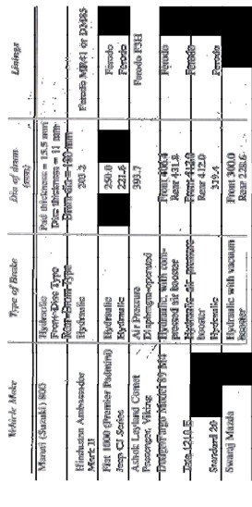

Paper - II Automobile Chassis and Body Engineering 119
The compressor sends compressed air to the-reservoirs which are connected to the brake. valve. The lines of tubing from the brake valve extend to the front and rear brake chambers. When the drive depresses the pedal, it operates the brake valve thus admitting compressed air to all the brake chambers. The compressed air operates the diaphragm of the brake chambers thereby applying the brakes.
3.7 List out types of Brakes used in various vehicles.
9
8
7
6
5
4
3
2
1
S.N

120 Automobile Engineering Technician
Summary
• Brakes are used to slow down or to stop the vehicle as and when required by the driver.
• Brakes are of two types
i. Internal Expanding brakes. ii. External contracting brakes.
• According to usage, the brakes are classified as
i. Mechanical brakes
ii. Hydraulic brakes iii. Air brakes
iv. Vacuum brakes
v. Air assisted hydraulic brakes vi. Hydrovac brakes etc.
• Requirements of Brakes
i. The brakes must stop the vehicle within shortest possible distance.
ii. These must be released suddenly immediately after releasing them.
iii. Total control of the vehicle should be ther.
• Mechanical brakes are operated through mechanical links and levers.
• These are used in two wheelers and in case of 4 wheeler. These are used as ‘Parking Brakes’ or ‘Emergency Brakes’.
• Hydraulic brakes are operated according to pascal’s law which states that “the pressure applied on any liquid is equally transmitted to all the directions at the same time.”
• Main parts of hydraulic brakes system are
i. Brake pedal
ii. Master cylinder iii. Brake pipe line

Paper - II Automobile Chassis and Body Engineering 121
iv. Wheel cylinder
v. Brake drum
• Air brakes are operated with the assistance of compressed air.
Short Answer Type Questions
1. What is the purpose of Brakes?
2. Define stopping distance?
3. Mention the main parts of hydraulic brakes.
4. On which law the hydraulic brakes work?
5. What is meant by ‘Brake bleeding’?
Long Answer Type Questions
1. Briefly explain the construction and working of mechanical brakes.
2. Explain the hydraulic brakes with neat sketch.
3. Explain the master cylinder with neat diagram.
4. Explain the brake bleeding process with sketch.
5. Explain the air braking system with sketch.

UNIT 4
Suspension System
4
4.1 Requirement of automobiles suspension system
The automobile suspension system is having the following requirement
(i) To have minimum deflection to the vehicles with required stabilit
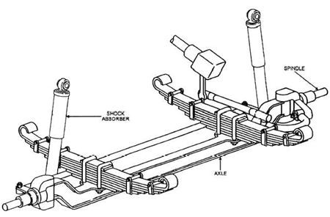. (ii) To have minimum wheel hop.
(iii) To safe guard the occupants and cargo against road shocks
(iv) To minimize the effects of stresses due to road shocks on the mechanism of the vehicle.
(v) To keep the body perfect in level while travelling over rough and uneven roads.
(vi) To keep the body of the vehicle safe from road shocks.
4.2 Types of suspension system - conventional and Independent
There are different types of suspension system provided in different vehicles. Those are
(i) Conventional suspension system
(ii) Independent suspension system
4.2.1 Conventional suspension system
In this suspension system. The wheels are fitted on beam type which are attached to the chassis frame through road springs. In this type of suspension, the effect on one wheel is directly transmitted to the other side wheel through the axle.

4.2.2 Independent suspension system
In this system the suspension for each wheel in an independent unit and in free from the effect of one another. There will be no effect of road shocks on the vehicle directly.
4.2.3 Types of independent suspension system
(i) Wishbone arm system
(ii) Trailing ling system (iii) Sliding pillar system
Wishbone arm system
Wishbone arm type independent suspension system is most popular type of all independent suspension system. In this system transverse springs along with coil, springs are mostly used. In European cars, torsion bars instead of coil springs are used. In this system there are two suspension or control arms are used in each side of the vehicle. There arm are like two legs of chicken wishbone or better ‘V’, . These wishbone arms are connected with chassis frame on the open end. The closed end spread out of the chassis frame. One arm is below whereas the other is above the frame. The closed ends of both upper and lower suspension arms are connected with steering knuckle support to which the steering knuckle is attached by means of kingpin. A coil spring is placed between the frame and the lower wishbone arm. Mostly the open end of upper control arm is connected with the sock absorber shaft which is fitted at the frame when there is a bump, the wheel tends to go up, the control since the shock absorber is fitted with the upper control arm, ti damps the vibrations set up in the coil spring due to road irregularities.
Trailing link system
The trailing link independent suspension use parallelogram linkages lying beside the frame side members usually a horizontal coil springs is used in this type of suspension system. During compression and rebound, the spring winds and unwinds . In some vehicles the torsion bar may also be fitted instead of horizontal coil spring.

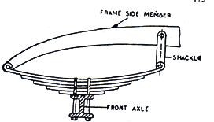

4.3 Types of Springs - Laminated Spring, coil spring, helical spring
The springs support the chassis frame. The entire weight of the vehicle live engine, power train, body, passengers, cargo etc, falls on the chassis frame. The spring damp the road shocks transmitted to the wheels as they travel over the road thereby protecting the units supported directly by the frame. The springs are placed between the chassis frame and the axle.
Types of springs
(i) Leaf springs
(ii) Coil springs
(iii) Helical Springs
(i) Leaf springs : The leaf springs are of different types namely-full elliptic three quarter elliptic, semi elliptic, quarter elliptic transverse. In almost all automobiles which are having conventional suspension system the semi elliptic leaf springs are most commonly.

Fig 4.2 Leaf Springs
The leaf springs are made of long flat strip steel. Several strips are placed one on the other and held together by means of centre bolt and champs. Each strip is called is leaf. There is one main leaf which is extended to full length.
Each succeeding leaf is shorter than the preceeding one. The main leaf contains eyes are both ends for making connections with the frame. The entire set is fitted from the chassis frame by hanging with a shackle at one side and the other side is fixed to frame. During jerks, the leaf spring bounces and each strip flexes and rebounces again and again.

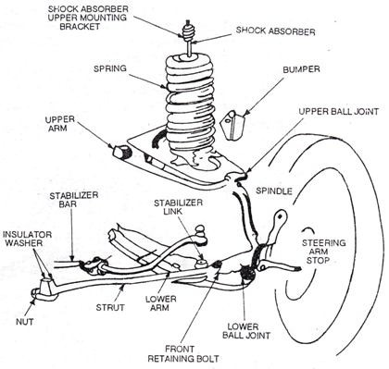

126 Automobile Engineering Technician
(ii) Coil springs : Coil spring is made of a length of special spring steel, usually round in section which is wound in the shape of coil The ends of coil spring are kept flat so that could seat properly . They can store twice energy per unit volume in comparison to leaf spring. To seat the coil springs pan shaped brackets or spring seats are attached to the axles. This suspension is also used in combination with torque tube or torque rod.

Fig 4.3 Coil Springs
(iii) Helical Springs : The helical springs are preferably used in combination with independent suspension system. The length and diameter of the spring wire greatly affect the stiffness of the spring. But the length is controlled by the diameter of the coil and the number of active coils.
4.4 Need of Shock absorber
Shock absorber compresses with the road shock and rebalances while travelling on uneven roads due to usage of this, the effect of road shock in required by the shock absorber suddenly and releases slowly whole travelling on uneven roads.

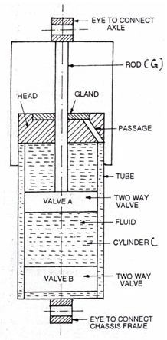

Paper - II Auto Chassis and Body Engineering 127
There shock absorber are of two types
(i) Mechanical type
(ii) Hydraulic type
Hydraulic Shock Absorber
The shock absorber develop resistance to the spring by forcing a fluid through check valves and small holes. ‘Double” acting shock absorber offer resistance both during compression and rebound of the spring. The ‘Double acting Hydraulic telescopic shock absorber ‘ are the commonly used shock absorber which are described as shown in the figure below

Fig 4.4 Hydraulic shock absorber
Its upper eye is connected to the axle and the lower eye to the chassis frame. A two way valve ‘A’ is attached to as rod ‘G’ . Another two way valve B is attached to the lower and of the cylinder C . The fluid is in the space above

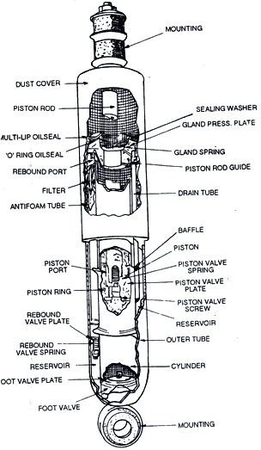

128 Automobile Engineering Technician
and below the cylinder C and tube D, which is connected to the space below the valve B. The J has glad H . Any fluid scrapped off the rod G is brought down into the annuler space through the inclined passage.

Fig 4.5 Hydraulic shock absorber(detailed construction)
When the vehicle comes across a bump the lower eye E moves up. Therefore the fluid passes from the lower side of the vehicle A to its types side .But since the volume of the space above valve A is less than the volume B. This pressure of the fluid through the valve opening provides the damping force. Similarly when the lower eye E moves down., the fluid passes from the upper side of the valve A to the lower side and also from the lower of the valve B to the upper side.

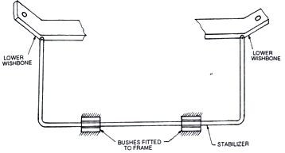

Paper - II Auto Chassis and Body Engineering 129
4.5 Stabilizers bar and torsion bar
4.5.1 Stabilizer
A stabilizer or a sway bar, is necessarily used in all independent front suspension units. It reduces the tending the vehicle to roll or tip and either side when taking a turn. This tendency has been increased due to the use of softer springs and independent front end suspension.

Fig 4.6 Stabilizer
A stabilizer is simply a bar of as long steel with arms at each and connected to the lower wishbone arm of independent suspension or to the axle. It is supported i bush bearing fixed to the frame and is parallel to the cross member. When both the wheels deflect up or down by the same amount the stabilizer bar simply turns in the bearings. When only one wheel deflects then only one end of stabilizers moves, thus twisting the stabilizer has which acts as a springs between two sides of independent suspension system. In this way, the stabilizer reduces healing or tipping of the vehicle on curves.
4.5.2 Torsion bar
In independent suspension system, the torsion bar is attached to the axle with the king pin of the front axle. The torsion bar axles the shock by moving in certain angle with the axle. It is almost being used along with any kind of independent suspension system. It is used along with rubber torsion units.

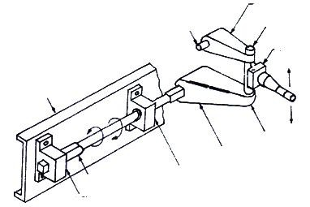

130 Automobile Engineering Technician

Upper Control Arm
Pivot pin Upper Ball Joint
Steering Knickel

Frame

Lower Ball
Lower Point
Control

Torison Bar Anchor
Bearing
Support
Arm

Fig. 4.7
4.6 List out the type of suspension system used in various vehicles

Front Suspension Rear Suspension
Sl. No. Make Type Type Shock Absorbers
1 Hindustan Independent Semi-ellipse Hydraulic tele-
Ambassador torsion bar leaf scopic double
Mark II acting
2 Fiat 1100 Independent Semi-elliptic Hydraulic tele-
coil springs leaf scopic double
acting
3 Jeep (J-3B) Semi-ellipse Semi-ellipse Hydraulic tele-
leaf leaf scopic double
acting
4 Ashok Semi-elliptic Semi-elliptic Hydraulic tele-
Leyland leaf leaf scopic double
Comet acting
passenger
5 Dodge / Semi-elliptic Semi-elliptic Hydraulic tele-
Fargo model leaf leaf scopic double
89 M4 acting

Paper - II Auto Chassis and Body Engineering 131
Summary
• Suspension system is provided to safeguard the occupants and cargo in the vehicle against road shocks and to give a smooth and comfortable drive.
• Types of Suspension drive
i. Conventional suspension system. ii. Independent suspension system.
• Types of Springs
i. Leaf springs ii. Coil springs iii. Helical springs
• Types of Independeng suspension system
i. Wishbone arm system.
ii. Trailing link system iii. Sliding pillar system.
• Shock absorber compresses with the road shock and rebounces while travelling on uneven roads
• A stabilizer is used in independent front suspension units. It reduces the tendency of the vehicle to roll or tip on either side while taking a turn.
• In independent suspension system, the torsion bar is attached to the angle with king pin.
• The torsion bar absorbs shock by moving in certain angle with the axle.
Short Answer Type Questions
1. What is the purpose of suspension system?
2. Mention the types of suspension system.
3. What is the purpse of stailbilzer?
4. What is meant by independent suspension system?

132 Automobile Engineering Technician
5. What is the purpose of shock absorber?
6. What is the purpose of Torsion bar?
Long Answer Type Questions
1. Briefly explain leaf spring with neat sketch?
2. Explain about a hydraulic shock absorber with neat sketch.
3. Explain the wishbone arm independent suspension system with a neat sketch.

UNIT 5
Seat, Door and Window mechanism
5
Method of door locking mechanism
Almost in all kinds of automobiles, the door locking mechanism is just closing the door and the lock will be automatically operated For unlocking any of the following methods may be applied.
(a) With a key
(b) By pressing the unlock button inside the vehicle
(c) By using a combination lock outside the door
(d) By pulling up the knob inside the door panel
(e) With a keyless entry remote control
(f) By a signal from control centre
Some of the vehicles, are having different methods of self check for door locking. It will warn you if is not properly locked by lighting the body light or beeping a horn etc. In power lock mechanism, body controller monitors are the possible sources of locking and unlocking signals. There will be an actuator in the door and a latch will be connected to the locking handle. When the actuator moves, it connects the handle to lock the door. To unlock it the body controller supplies power to the door lock actuated for timed interval.

A key less remote entry device consists of a fob in the key ring and a radio receiver controller inside the car, which opens and closes the car doors on the receipt of a signal form the fob.
5.2 Construction and working of Manual window regulating mechanism
In cars and in some luxury vehicles, the window glasses can be operated for opening and closing to some extent as per the necessity. This can be done of manually or by using a single button of at each window or by using a panel of buttons at the control of the driver.
In olden days only manually operated window regulating mechanism were being used. There will be handle inside the door to regulate it. This can be operated manually by rotating the handle to the extent required . There will be a wheel inside of door panel which is connected to this handle.
5.3 Construction and working of Power window regulating mechanism
In modern days the window regulating mechanisms are being operated with power. By using the switches the height of closing and opening of window

glasses can be regulated. It is operated with electricity from the battery. In some cars, these can be operated with remote control.
5.4 Construction and working of Seat Adjustment mechanism
In automobiles the seat adjustment plays an important role in almost all kinds of vehicles. The seat should be in proper manner for comfort sitting as per the requirement of the operator. The space between the seat and operation pedals like accelerator, clutch, brake etc. Should be in a proper manner that the operater can reach them and it should be as long as possible if the operator is tall. The seat can be moved to and from the front dash board. Its height also can be increased or decreased as the case may be .
In buses of high comfort, the passenger seats can be adjusted according to the requirements . These can be adjusted like an easy chair for a comfort sitting or even for sleeping.
The seats used in cars are of various types such as rigid, folding back and bucket type . The front seats may be single type or full bench type with seat cushion and back rest . In case of two doors cars, the seat back rest in folding type, so that it swings forwards to allow access into back seat. Front seats are provided with adjustment that allows the seat to move back and forth or up and down as per the requirements. These adjustment are done manually or by using electric motor also.
Short Answer Type Questions
1. What is the purpose of window regulating?
2. Howmany types of door locking mechanism are there.
3. What is the necessity of seat adjustment?
Long Answer Type Questions
1. Briefly explain manual and power of operated window regulating mechanism.

UNIT 6
Air Conditioning of Motor Vehicles
6

6.2 Construction and working of passenger car air conditioning
The automobile air conditioning system includes compressor magnetic clutch condenser, receiver-drier -strainer , expansion valve, evaporator, blower and the air distributor system.
Compressor : It is driven by a belt from the crankshaft pulley. A magnetic clutch engages the compressor shaft. The applied voltage to compressor clutch coil, the clutch plate is locked by the magnetic force and the compressor shaft is turned with the pulley. When the voltage is interrupted the springs in the clutch plate and hub assembly automatically moves the plate away from the pulley which causes the compressor to stop. The compressor compresses the refrigerant to a maximum of about 20 kgf/cm² at 100⁰C.
Magnetic clutch : It is essentially controlled and is housed in pulley assembly. It’s controlling switch is provided in the controlling panel. In the off or vent position the compressor and its clutch are off. In other four positions of the selector switch, the clutch is engaged or disengaged depending upon the temperature of air.
Condenser : Condenser is basically a fin and tube radiator .It is usually placed in front of radiator .It receives heated and compressed refrigerant vapour from the compressor and is cooled by the air passing across the condensers.
Receiver - driver (or Dehydrator )
The refrigerant is stored under pressure in the receiver-driver. The pressure in the receiver lies in between 5 kg/cm2 to 20kg f/cm² depending upon the compressor speed and surrounding air temperature. The drier removes any traces of moisture present in the system to avoid freezing of moisture at low temperature. Drier is usually a silica gel filter that absorbs any water.
Expansion valve : The refrigerant goes from dehydrator to expansion valve where a sudden expansion to a much lower pressure occurs. The refrigerant changes back to vapour state and this causes cooling effect. It is operated by opposing pressures on either side of the diaphragm
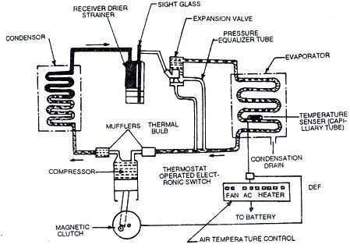

Evaporator : It is located inside the passenger compartment. It gives cooling effect . A high capacity blower circulates the air in the interior part of the vehicle across the evaporator coils and this drops the temperature. The heat picked up by the refrigerant goes back to the compressor in the form of vapour where the refrigerant is again compressed to a high pressure.
Suction throttling valve : It ensures that the refrigerant in the evaporator stays at such a pressure that the evaporator core surface temperature does not fall below the freezing point of water (0⁰C), thus preventing ice formation in the evaporator.

Fig 6.1 Automobile air-conditioning system
Short Answer Type Questions
1. What is the necessity of Automobile air conditioning?
2. What is the working principle of automobile air conditioning?
Long Answer Type Questions
1. Briefly explain the construction and working of Automobile air conditioning with neat sketch.

